Week 5: Database Components and CRUD Operations

5.1 Building Database-Driven Web Applications

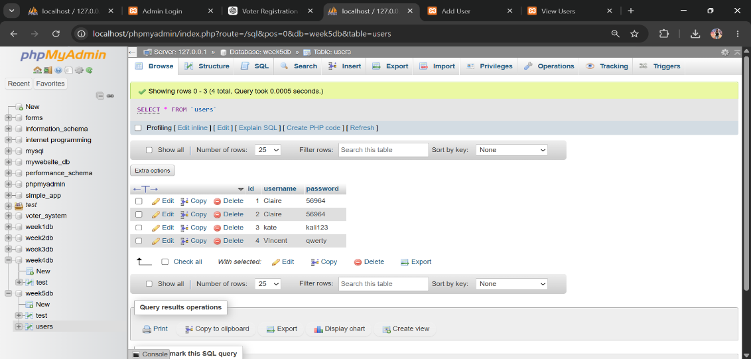
Figure 21: Users Table Creation
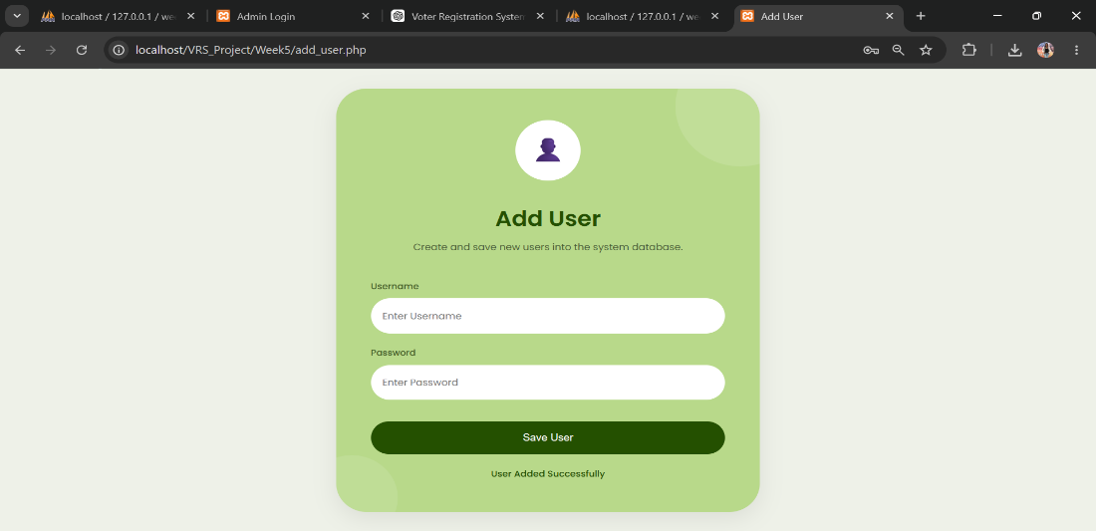
Figure 22: User Record Insertion
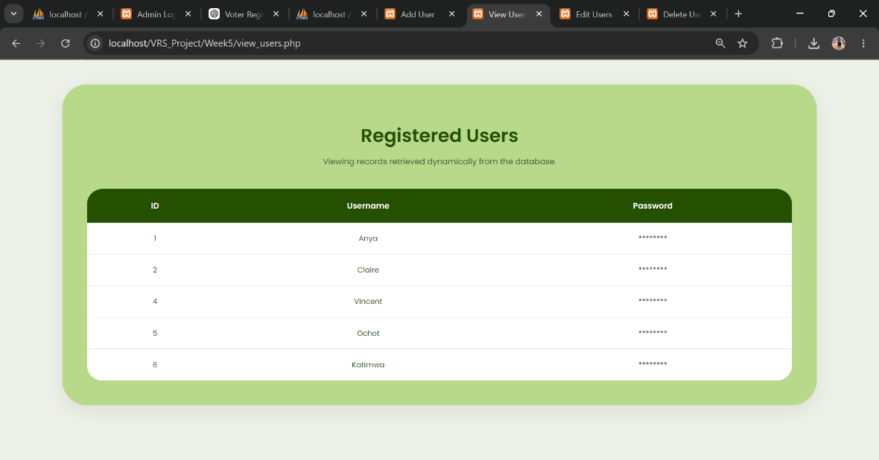
Figure 23: Displaying Database Records

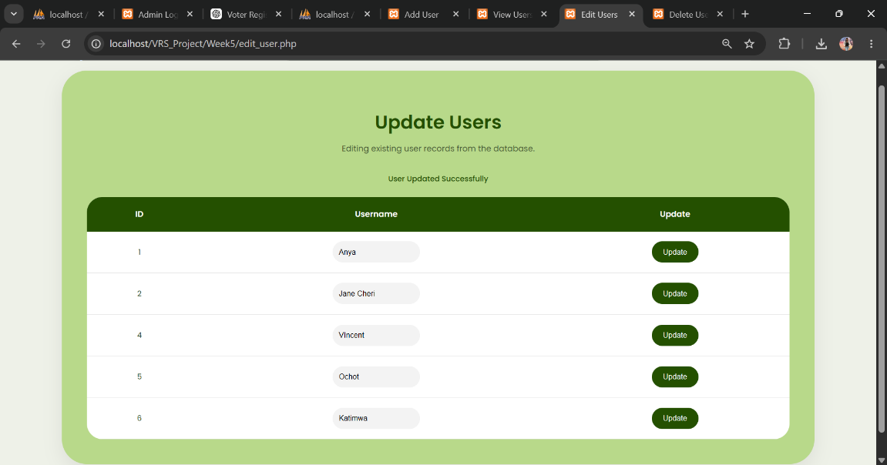
Figure 24: Updating User Records

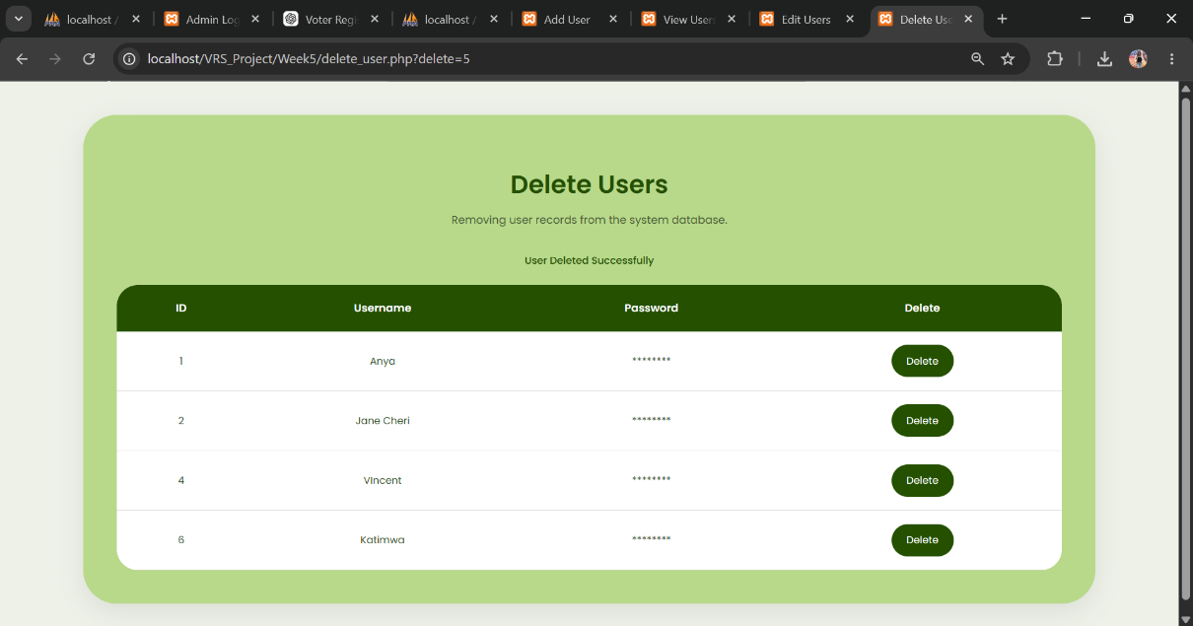
Figure 25: Deleting User Records

